Daughters of the American Revolution

DAR) Good Citizen Award
(

The faculty and senior class of Beal City High School
are proud to announce Rachel Pung as their DAR Good
Citizen recipient for the 2015
-
school year. The
2016
selection process for the DAR Good Citizen is based on the
qualities of Dependability, Service, Leadership, and
Patriotism.

Throughout her high school career Rachel has been
involved in National Honors Society (current treasurer),
Spanish club (current President), the GI
-
Tech Center as part
of the Educational Career Leadership Club (current Vice
President) and her youth group through church. She has
also participated in basketball and marching/concert band.

ESS
THE AGGIE EXPR

B E A L C I T Y P U B L I C S C H
O O L S

Newsletter Date November, 2015

Rachel was nominated by the high school faculty and then selected through a voting process by her classmates. She is the daughter of Paul & Kelly Pung. Rachel plans to attend Central Michigan University in the fall and pursue a degree in Early Childhood Education.

Veteran’s Day Assembly Announcement
Beal City Public Schools will be hosting a Veterans’ Day Ceremony to honor veterans and present members from each branch of the US Military. If you are a veteran or a current member of the US Military, please attend the Veterans’ Day Ceremony that will be held in the Beal City Public School big gymnasium starting at 10:00 am on Wednesday November 11, 2015. The whole program will last about 45 minutes to an hour. The entire community is invited and if you know of someone who is a veteran or a member of the US Military please let them know about the ceremony. It would be nice to have a large crowd attend this event to honor those who have served and fought and those that are serving and fighting for our country today to preserve our way of life here in the USA.
If you are a Veteran or a member of the US Military and would like to be included in our power point presentation please drop off a military picture with your years of service, info on where you were stationed, your rank, and the duties you performed.
After the Ceremony we will have a luncheon in the Media Center for all of the veterans and their spouses.

***Staff Member of the Month***

The Beal City Board of Education, in appreciation of the hard work that is done by all staff members of Beal City Public Schools, would like to honor a staff member each month for their service to the students and community of Beal City. This month’s honoree is Theresa Lambourn.

Terry has been a paraprofessional at Mayes Elementary for 4+ years. Not only as an employee, but also as a longtime community member and supporter of Beal City Schools, Terry always wants the best for our school and our students. Over the last couple of years, Terry had voluntarily
spearheaded the planning, fundraising, and construction of the elementary playground remodel. Mrs. Lambourn put in countless hours of her own time over the last year and a half, in taking this project from an idea to completion. In conjunction with the School’s PTA, Terry wrote grants, sought out donations, requested bids, assisted in fundraising, and was at the school all summer, helping in every aspect of the construction of the playground build. We are all very grateful to Mrs. Lambourn for her part in making our playground something that Beal City students will be able to enjoy for generations to come.

Board Briefs

The following was approved at a regular board meeting on October 19, 2015:

- General Fund payments of $307,160.40, hot lunch payments of $11,526.39 and Athletic Fund payments of $6,332.77.
- The Audit as presented.
- 1st reading of the Neola Policies as presented.
- The following coaching recommendations: Cam Gatrell – Varsity Boys Basketball and Dan Beckwith – 8th Gr. Boys Basketball.

To locate the Beal City Board of Education agenda and minutes from the monthly Board meet- ings, please see the Beal City website. Click on District Info, Board of Education, then click on the Board of Education on the left hand side to receive a menu. From there click on Meeting.

R.J. Schafer Teaches History… Again!
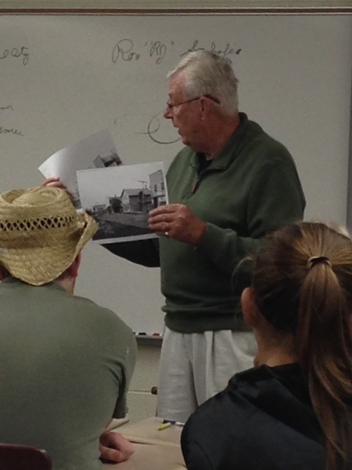

On October 5th, R.J. Schafer shared his time and talents when he came to the High School to teach the history of Beal City’s community, church, and schools to Mrs. Davis’ high school history classes. Students listened as Mr. Schafer explained the German heritage of the
community, the history of the schools (including the natural disasters that occurred), and the importance of the church to the development and the people of Beal City. R.J. expressed his confidence in the Beal City student’s future, telling them that “faith, family, and friends” have made this community a place which produces people with good character and work ethic that are prepared to experience success in life.

Feature Staff Person

Beal City Schools would like to introduce Roni Sisco as our new Para-Pro. Roni and her husband Blake have been married for 10 years and have three children; Rylee – a 5th grader and Jaylyn a 2nd grader both at Carl Mayes Elementary and Gavin who is in Pre-K. Roni has an Associate’s Degree from Alpena Community College where she played basketball, volleyball and softball.

Cruise & Nora Roberts. Her favorite foods are salad and chocoWhen Roni has time to read she likes to read books by Jennifer
late and she loves her coffee!!! Roni loves spending time with her family, going for walks, camping, and traveling up North to visit her family and she also loves to bake.

This past summer she took the kids to Mackinaw City/Island for a few days where they visited the Butterfly House, Fort Michilimackinaw and The Grand Hotel. Then they traveled to St. Ignace to go to Castle Rock and the Mystery Spot! It was one of the highlights of their summer.

We are very excited to have Roni with us at the elementary. Wel-
come aboard Roni!!!

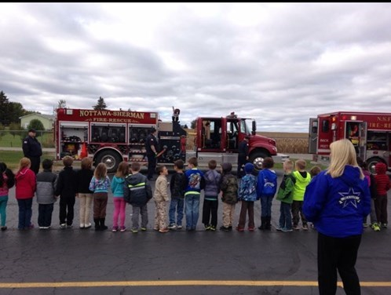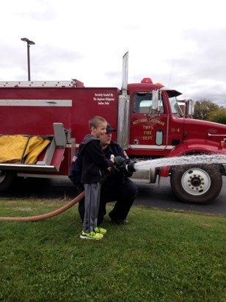
Thank you Nottawa-Sherman Fire Department!
The Pre-School, Kindergarten, and First Grade classes had a fantastic time learning about Fire Safety in October! The Nottawa-Sherman Fire
Department volunteered to visit Beal City School with fire trucks, firemen, and gear. Each student even got to use the fire hose! They were taught to call 911 in case of emergencies, stop-drop-roll if their clothing was on fire, and to create an emergency plan with their family in case of a fire.
John Schultz even put all of his gear on so that children could see and hear what a fireman would look like during a fire. He told the children not to be afraid if a fireman came into their home, to never hide, and yell as loud as they can.

Microsoft Office Free to Beal City Staff & Students
Attention all Beal City Public Schools staff and students: We are now all eligible to download and install Microsoft Office 365 on up to 5 personal computers/devices FOR FREE!! This is not a trial offer or a limited version of the software suite. PCs, Macs, iOS, Androids – get Word, Excel, PowerPoint, etc. on all of your devices by heading to this website: https://products.office.com/en-us/student/office-in-education. Once there click the “Get started for free” button and then enter your bealcityschools.net or bcaggies.net email address. You will then receive an email from Microsoft with instructions on how to complete the process. You only need to register once – after that you can go to https://portal.office.com and log in with the credentials you created in the previous step. You’ll then be presented with links to download and install the Office apps onto your device OR use the online versions of the apps. Enjoy! (If you’d prefer clickable links this article is currently posted on the front page of bealcityschools.net. If it’s been removed by the time you go there you can also find it at bealcityschools.net->Departments->Technology.)

1
of
1

Beal City Education Foundation Thanks

Supporters

The BCEF would like to thank the many sponsors that supported the “Rock The Foundation” Halloween Bash. Because of YOU, Beal City students have opportunities that other schools do not offer. The BCEF’s goal is to provide every graduating student from Beal City a scholarship to go to college or trade school. With the communities support and the support of the businesses in the community this goal can and will be achieved! Please support these sponsors, as they are supporting your kids and please thank them for supporting the BCEF.
Thank you very much sponsors, we couldn’t do this without you!!!
Absolute Granite | Hangin' By A Thread
Bandit Industries | In Loving Memory of Joseph W Kovacs Jr – Chris & Denise McBride
Brickner Agency – Farm Bureau Insurance | Isabella Bank
Central Michigan Sand & Gravel | JBS Contracting
Charles R. Lux Family Funeral Home and Cremation Services | Martins Kountry Korner
D.N. Rau Inc | Mission Lumber Inc
Dewitt Lumber Co | Pioneer Oil Tools Inc
Edward Jones Of Mt Pleasant, Mark Smith, Amy Hovey, Greg Starry, Mark Cashen | Pohls Dairy Farm
Esther Haupt Tax Service | Pure Plumbing LLC
Finnerty Builders | Schumacher Farms
Fraternal Order of Eagles Aerie 4540 | Soaring Eagle Casino and Resort
G & S Mechanical LLC | Straus Masonry, Inc
Gentle Family Dental Center | Tilmann Hardware Inc
Gleaner - Mt Pleasant Arbor | Wilson, Sharrar & Freeze PC
Gross Dairy Farms | Yuncker Marine LLC
 | Zeien Farms

The annual Mayes Elementary Holiday Program/Senior Citizen Reception will take place on Friday, December 18th, 2015. The Senior Citizen Reception will begin at 12:30 p.m., with the Holiday Program following at 1:00 p.m. Both will take place in the elementary gym. Come out for an afternoon of fun and entertainment!
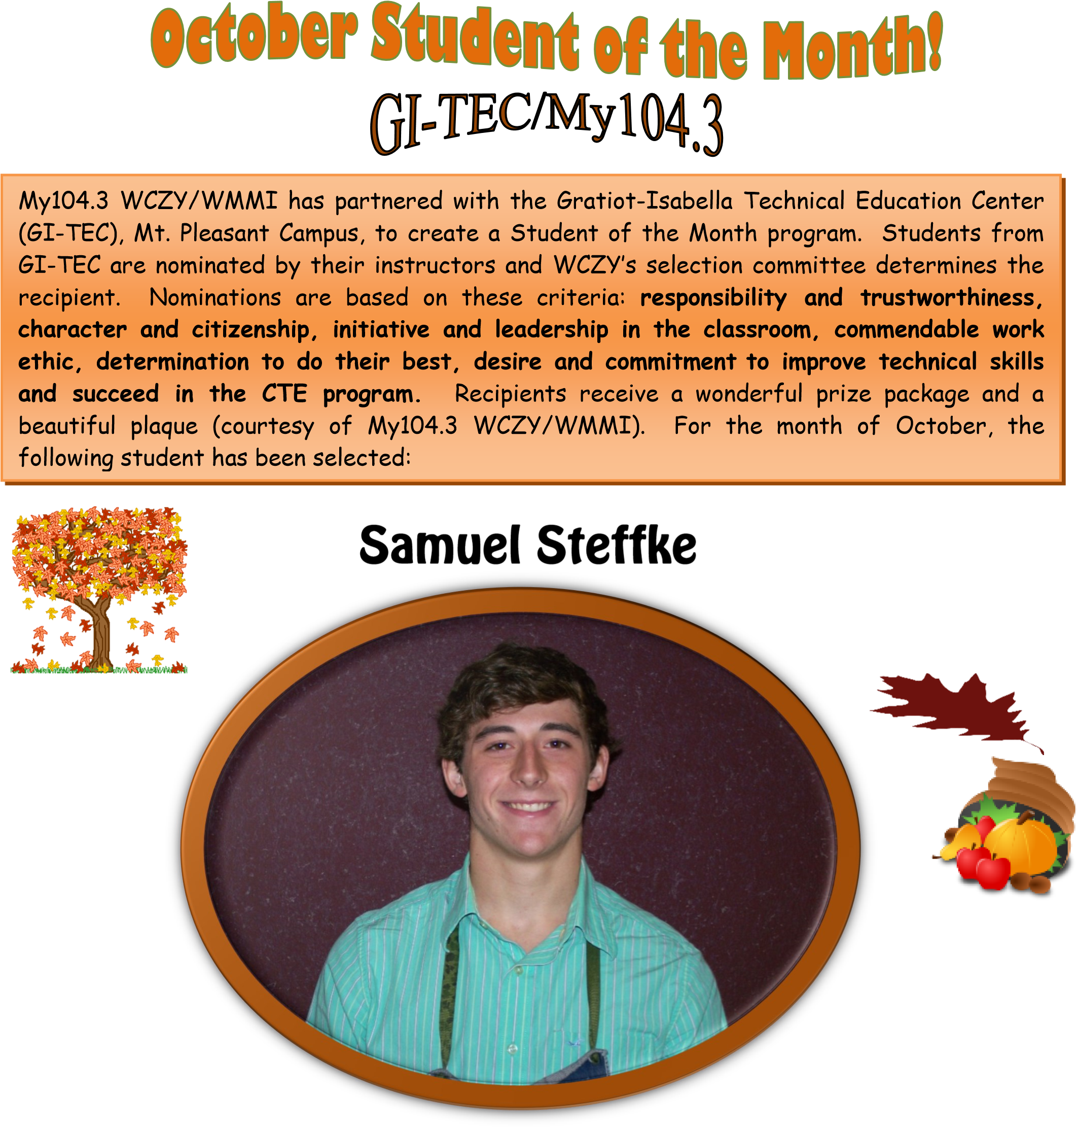

Sam was nominated by his Machine Trades instructor, Mr. Paul Driggers, who had this to say about him:…….”This is Sam’s second year in Machine Trades at GI-TEC, Mt. Pleasant Campus. On day one of this class, Sam was one of the first students to say hello, shake my hand, and introduce himself. His leadership is shown in the way he steps up and works with new students in the class, helping them to understand the concepts. His machining skills continue to improve and his questions have some real thought behind them--he’ll have a solution or two for whatever problem presents itself, and wants to make sure he stays on track and finds the answer.

Sam is in the starting lineup for the Beal City Aggies football team. He is in Youth Group at St. Joseph the Worker Parish, works for the Isabella County Parks and Recreation, and is a member of the Isabella Sportsmans Club. Sam enjoys hunting and fishing in his off time. After graduation, he plans to enter the
Manufacturing Program at either Mid-Michigan Community College or Delta Community College.”
Mayes Elementary
SEPTEMBER Students’ of the Month
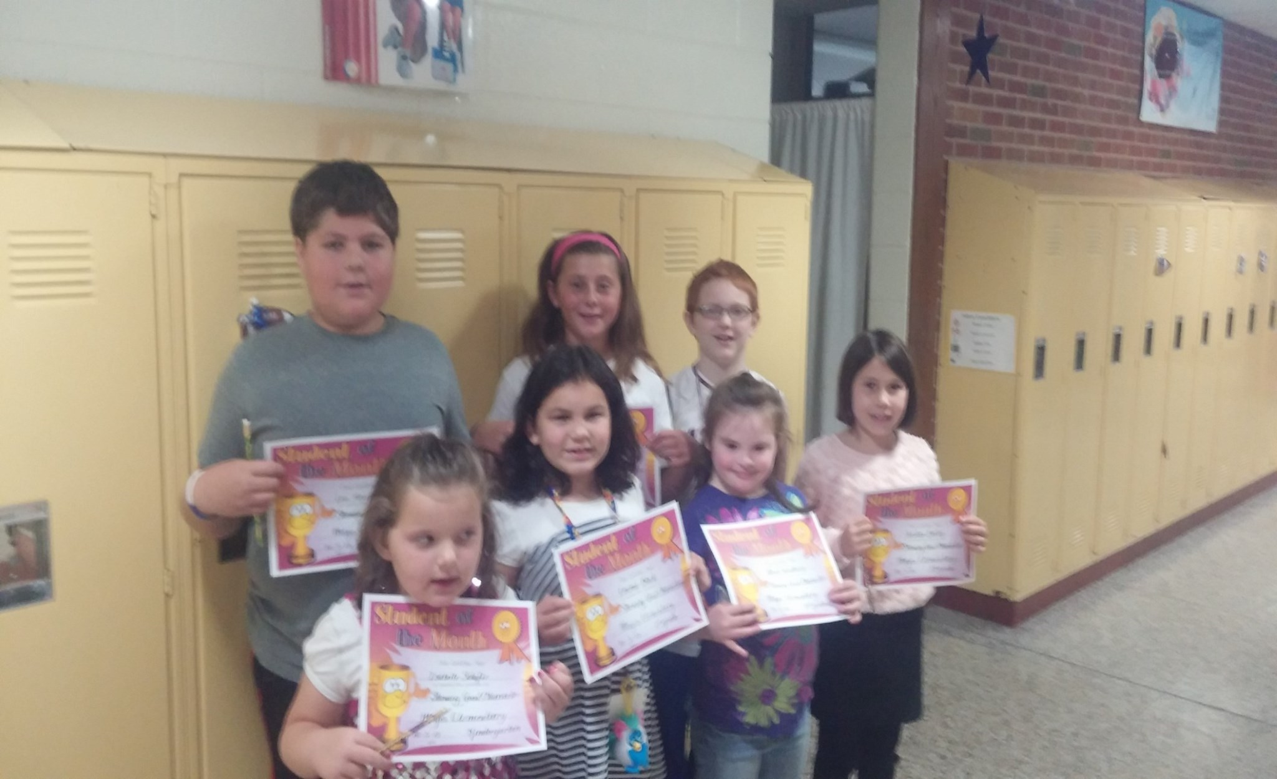
Back Row Left to Right, Levi Hazen (4th grade) son of Levi & Kay Hazen, Sami Ames (6th Grade) daughter of Ryan & Jen Ames, and Daniel Perreault (4th Grade) son of Kyle & Kelly Perreault. Front Row Left to Right, Isabelle Schafer (Kdg.) daughter of Cory & Jamie Schafer, Emma Block (1st Grade) daughter of Rich & Becky Block, Aleah Woodbury (2nd Grade) daughter of Paul Woodbury & Tara Scully, and Jordan Bailey (3rd Grade) daughter of Kevin & Jolynn.

Winter Clothing

It’s that time of year again! Now that colder temperatures have finally arrived, we wanted to remind parents of our “Seasonal Clothing” policy, in the Parent/Student Handbook. When the temperature is 41 – 50 degrees, coats or sweatshirts are necessary. In addition, at 40 degrees or below, coats, boots, gloves and hats are required for ALL grades, and snowpants are recommended. If a student comes to school unprepared to go outside, he/she will receive a warning the first time, and remain on the blacktop. If cold weather clothing is forgotten more than one time, students will have to stand against the wall or serve lunch detention. At all times, best judgment in accordance with weather conditions is expected. Remember, it could be warm in the morning and cool off throughout the day. We do live in
Michigan!! It’s better to pack the extra winter gear than to be caught without it when the weather turns.

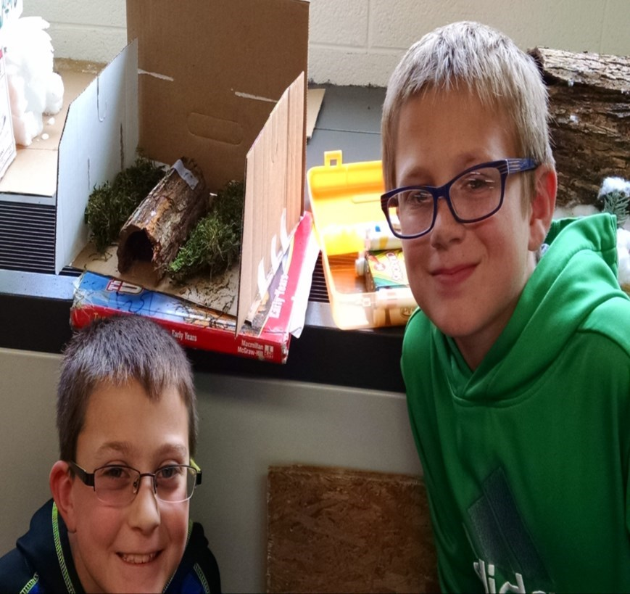
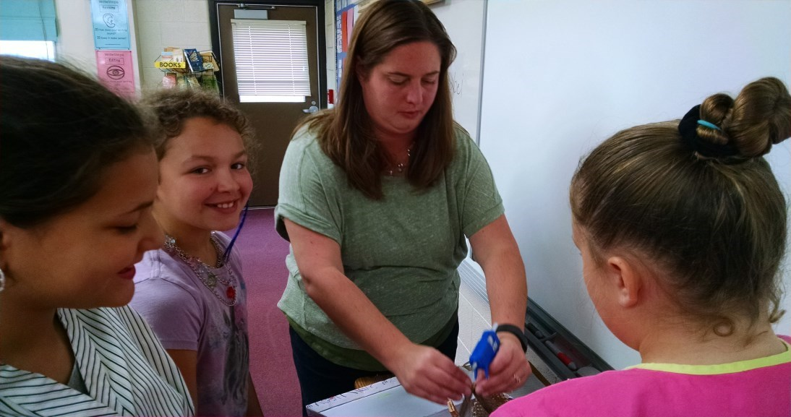
Taylor Onstott, Hadyn Armstrong and Elaina Carnes showing off their Igloo.
Cayden Winegardner and Kayden Cotter showing off their longhouse.
Mrs. Gottschalk was the hot glue person.
Taniel Hernandez, Janice Gardner, and Audree Goffnett wait patiently for their turn.
5th Graders Learning About Native Americans
In Social Studies this first marking period, the fifth graders have been learning a lot about the native people of North America. We learned how the Native Americans settled the Americas and also why different groups settled where they did. This taught us about the Native Americans of the West, the Southwest, the Plains, and the Eastern woodlands. By focusing on the different
groups, we learned that a lot of the stuff they did was based on the area they lived in. Throughout this first unit, we learned a lot and the students then had to build their own Native American shelter. The students had a blast and the projects turned out 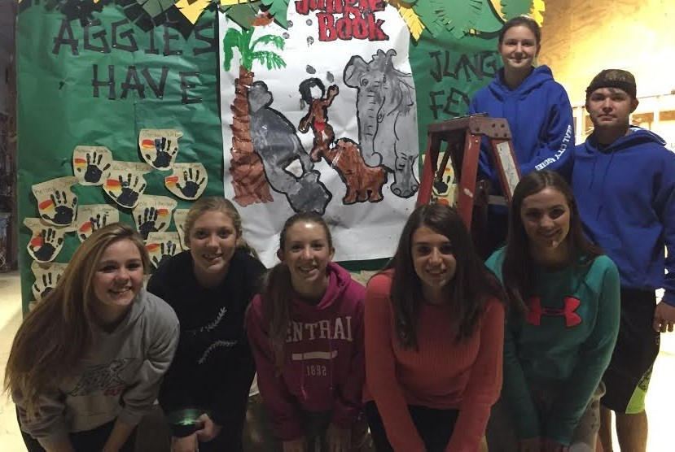awesome.

Project PALS – Fall Fun!
The 2nd grade students from Mrs. Smith’s and Mrs. VanBlargan’s classrooms have met and joined their high school PALS from Ms. Spry’s class to engage in some great Fall activities! Attending the local play, “Charlotte’s Web”, in Mt. Pleasant started the season off perfectly! It was a great performance and loved by all! Next came Homecoming and as usual it was very exciting for everyone as the students had a great time at float building and riding in the parade. Our month came to an end getting together with our PALS to paint their favorite face on pumpkins for Halloween. We send special thanks this month to: Mr. Wolf, John and Esther Haupt, Jason McDonald, Mr. Pung, and all of our parents for their support!!

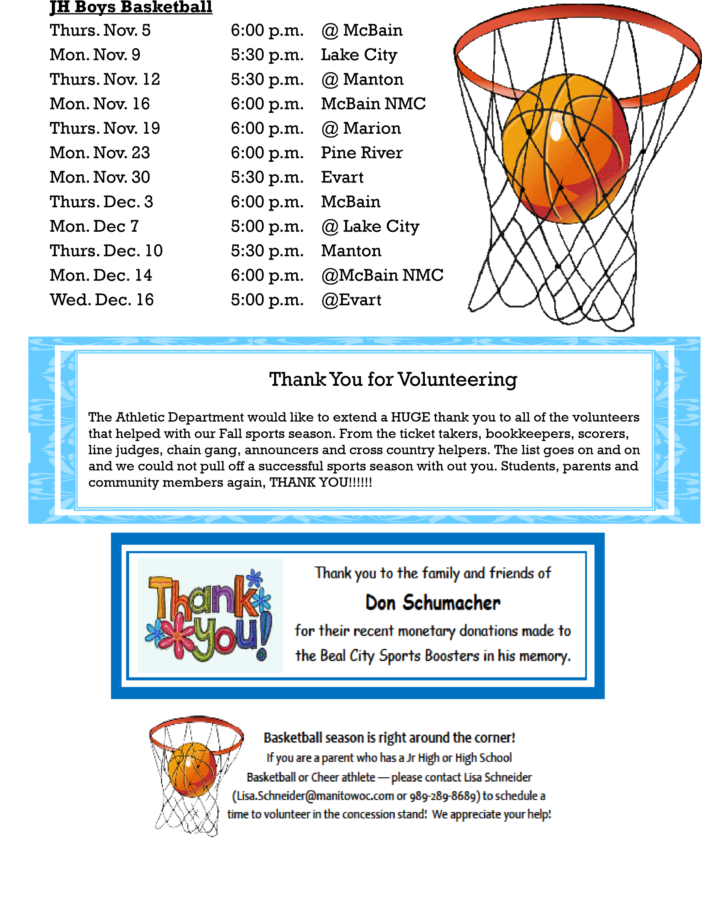

WE NEED YOUR HELP

Custodian and Bus Driver Subs Needed
Beal City Public Schools is looking for custodial and bus driver subs. All custodial subs will be paid by a third party management company but will be called by our staff to cover custodians when they need time off. Hours of work will be from 4:00 p.m. – 12:00 a.m. Bus Driver subs will be used to sub for our regular route drivers and take trips when regular route drivers are not available. Please contact Jason McDonald at 644-3901 to get more information on custodial and bus driver subbing.
School Breakfast - Good for Kids and Good for Parents!

For parents with busy schedules, it can be hard to make sure that kids are eating a healthy breakfast before they go to school in the morning.

Sometimes children aren’t hungry right after waking up, and it’s hard to find food they like to eat that is also healthy. Also, some kids refuse breakfast at home but are hungry when they arrive at school. At school, we have a great breakfast program for all students.

If morning meals are difficult for your family, let the School Breakfast Program help you out!

Every morning our breakfast consists of these whole grain items: assorted pop tarts, muffins, uncrustables, donuts, cereal, yogurt, juice, cheese stick and milk. Students must choose a fruit and 2 grain items.

Location: Aggie Cafeteria
Breakfast time every day: 7:40-8:05
Full pay price: $1.50
Reduced: $.30

Remember, no breakfast will be served if we have a delay.

Wellness Goals 2015

- Farm to school-we will participate as long as there is availability.

- Apple Crunch- We will participate in this every year. Providing everyone in our school with an apple.

- No fundraising during the school day unless it meets the smart snack guidelines. Mr. Chilman will monitor this because he approves all fundraising.

- Mr. Fletcher’s Health Class will present nutrition facts/findings to Beal City and St. Joe elementary school students.

- Marci will be working at least once a year in the classroom with Mr. Fletcher’s Health Class.

- Updates on our goals in the Aggie Express and on the website.

- Posters will be posted in cafeteria about health and wellness.

- Inform the public through Aggie Express and website at least once a year.

- All ala carte items will meet the smart snack guidelines

- Elementary will stay involved in the “backpack program” (sending food home on the weekends to feed free students eligible for free lunch) as long as it is available to us.

- Wellness survey HSAT completed every other year.

- Posters about the harm of tobacco are completed by Mr. Fletcher’s Health Class and hung up in the hallway.

- Posters about nutrition are completed by Mr. Fletcher’s Health Class and hung up in the hallway.

- Marci will monitor and keep track of completing these goals.

The link to read our Wellness Policy is on the Food Service page of our website under Wellness Resources. If any community member, parent or student is interested in joining our Wellness Committee please contact, Marci Faber or William Chilman at 989-6443901.

Compete in Beal City’s Annual

TALENT SHOW 201
5

Hey Aggies, can you act, sing, dance, play an instrument, or perform magic
or gymnastics? Are you in a band? Maybe you mock rock, write or perform
poetry, or have another cool talent we haven’t thought of or seen yet! If you
answered yes to any of
these questions, come out and show your Talent!
Beal City High School’s annual talent contest is approaching fast, so get
your act together! Auditions are

October 26
–

29

by
arrangement:

See or call Ms.

Holt
in room 310

of the high school or email:
gho
lt
@beal
cityschools.net
.

DRESS REHEARSAL is November 1
6
th
,
3

-
5:30

PM

PERFORMANCE is November 1
7
th
, 2015

at 7pm

November 1
7
th
, 201
5

7
PM
:00

Beal City Public Schools NON PROFIT ORG
3180 W Beal City Rd US POSTAGE Mt. Pleasant, MI 48858 PAID

SAGINAW MI PERMIT NO 269

Elementary Calendar of Events

November 2 | PTA Meeting, 5:30pm – Media Center
November 6 | End of Marking Period – ½ Day for Students
November 7 | Apple Pie Fundraiser (Volunteers – 8am-12pm & pick-up
 | 10am-12pm)
November 9-19 | Holiday Wreath Fundraiser Orders
November 9-13 | Book Fair
November 12 | Parent-Teacher Conferences, 8am-12pm, 1-3pm, 5-8pm
November 23 | 2nd Grade Project PALS Turkey Dinner & Program, 6pm
November 23 | Holiday Wreath Pick Up, 2:30-6:00pm
November 24 | Holiday Wreath Pick Up, 2:30-4:00pm
November 24 | LifeTouch School Picture Re-Takes
November 26-27 | Thanksgiving Break
December 7 | PTA Meeting, 5:30pm – Media Center
December 18 | Holiday Music Program, 1pm – Small Gym
December 23 | First Day of Holiday Break
January 4 | School Resumes

